# Setup Database

How to get started API / Web

Product Manager

Zain Nabi

2023

1. Go to sql server and connect using windows authentication
2. Open a new query window and paste script on window
3. Execute script by pressing F5 or execute button
4. Wait for command to complete
5. Database will now be created

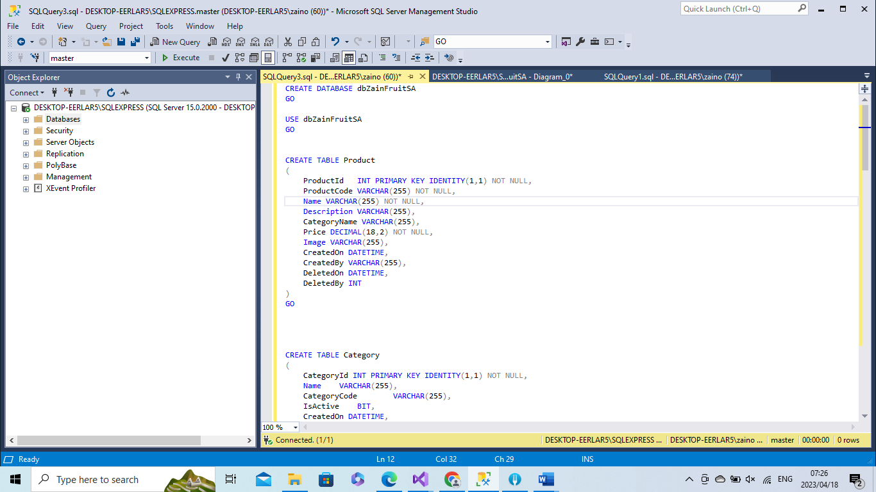

# Download Project

1. Go to gihub code repository and download zip project for API

<https://github.com/zain-nabi/Productmanager.WebApi>

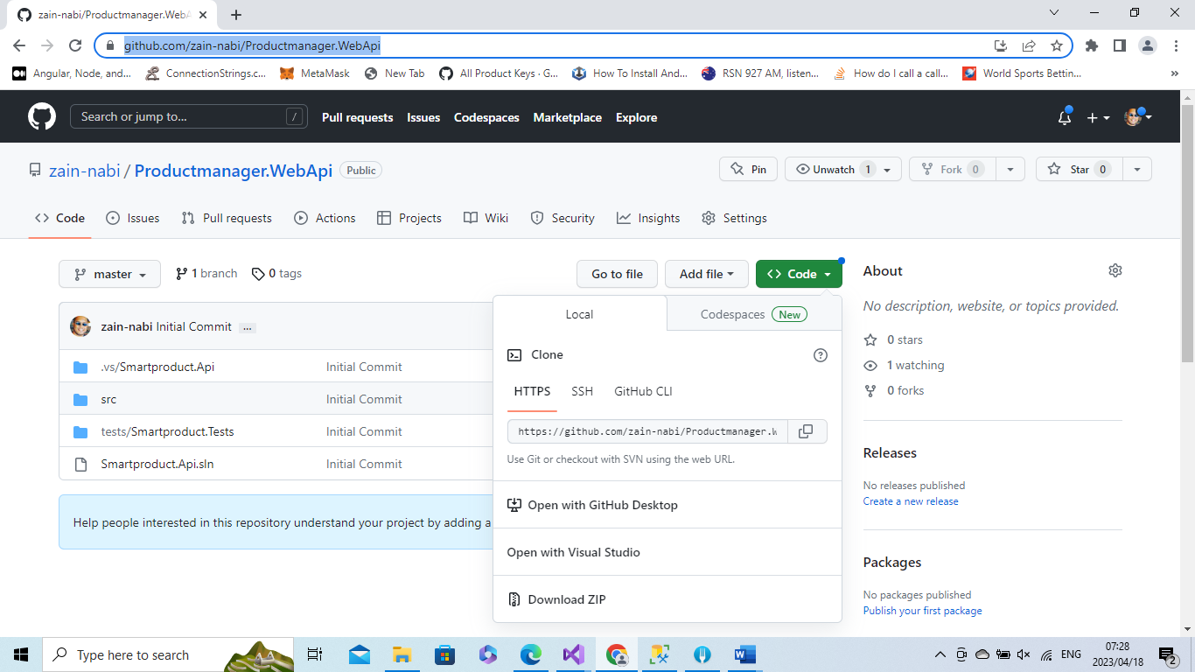

1. Download web project using zip option

<https://github.com/zain-nabi/Productmanager.Web>

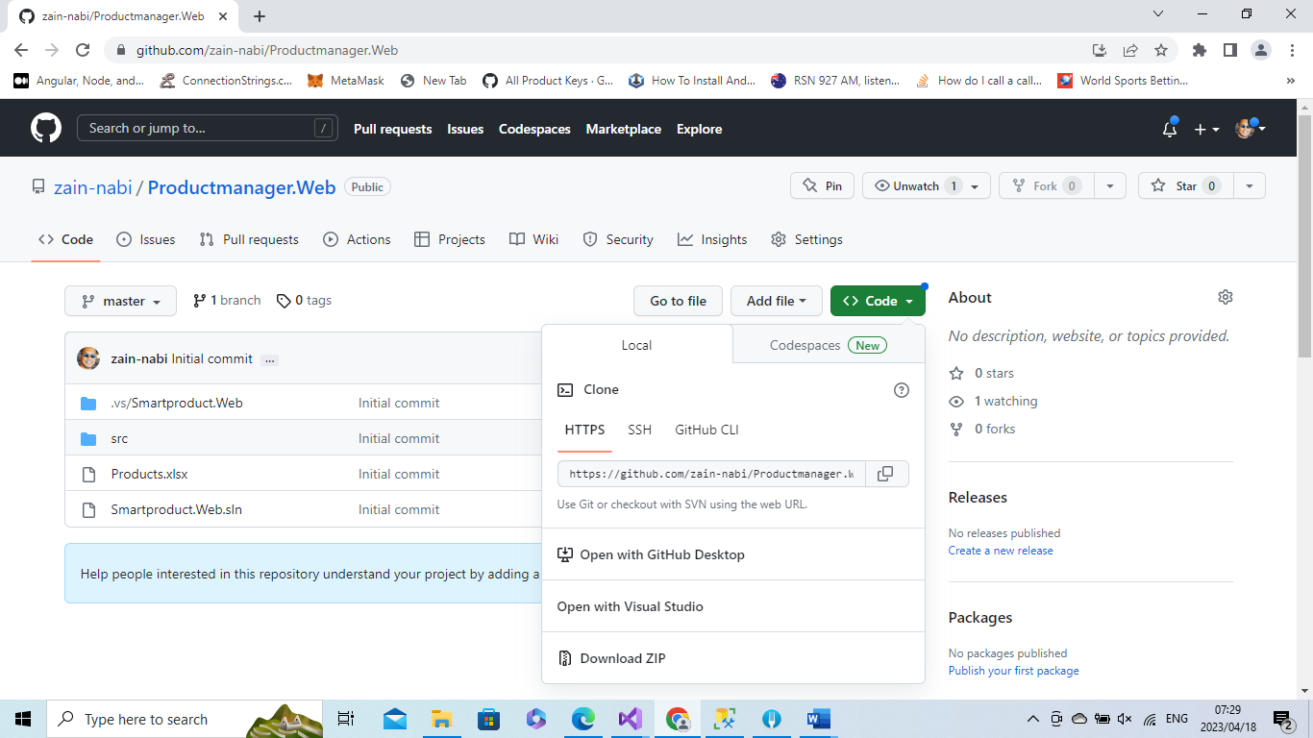

1. Once downloaded extract each project to a new folder

# Open Smartproduct.Api solution File (Visual Studio 2019)

1. Open project right click and select visual studio 2019

# Open Smartproduct.Web solution File (Visual Studio 2019)

1. Open project right click and select visual studio 2019

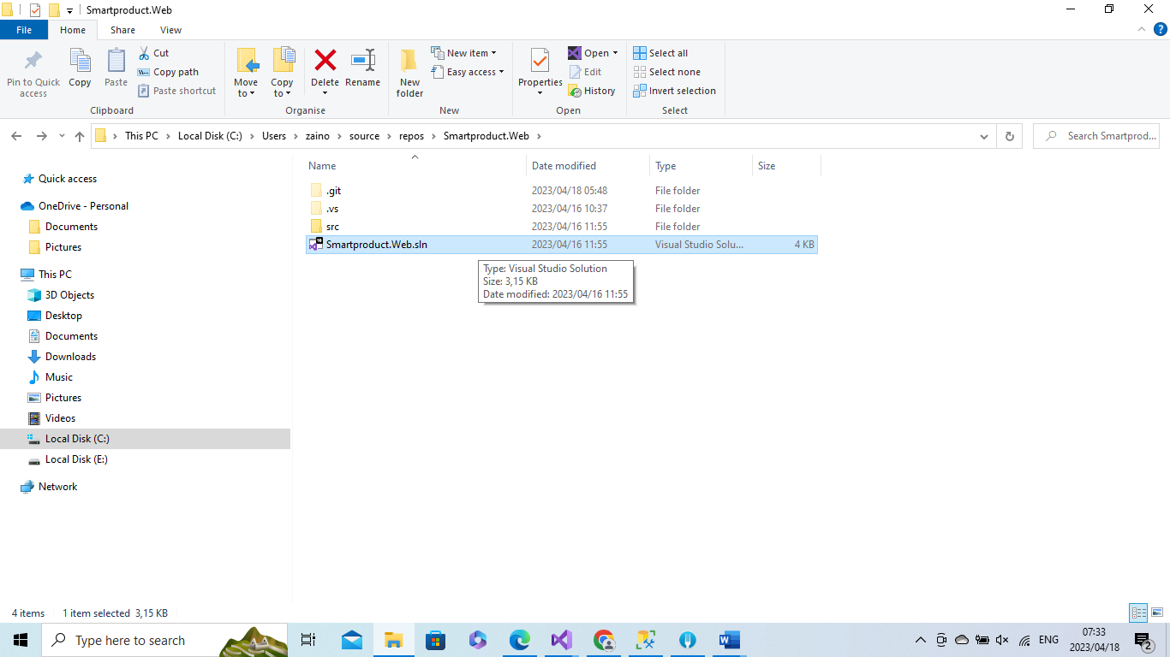

# Change appsettings Connection string (Visual Studio 2019)

1. Under src folder, dropdown and further drop down project Smartproduct.Api
2. Double click appsettings.json to open up

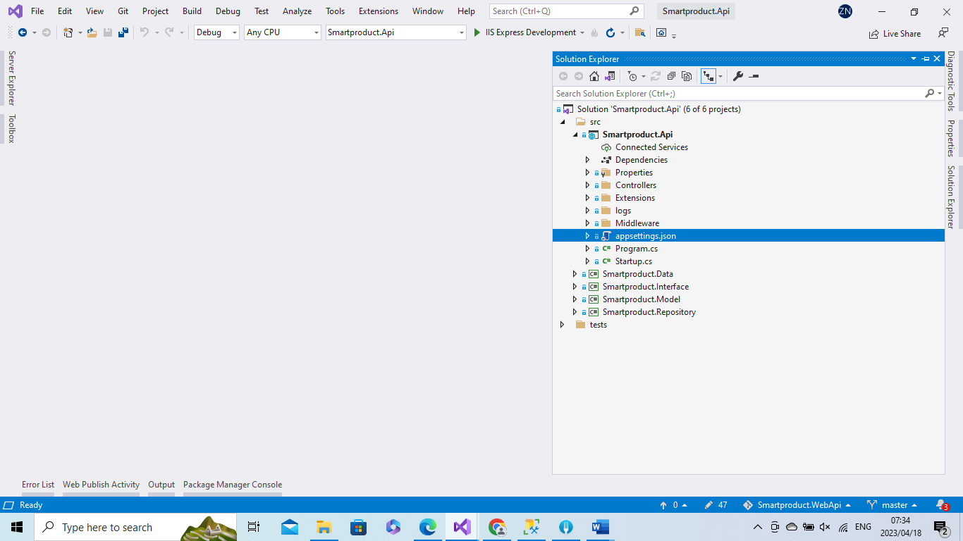

1. Change Connection Strings Node to use your SQL server name

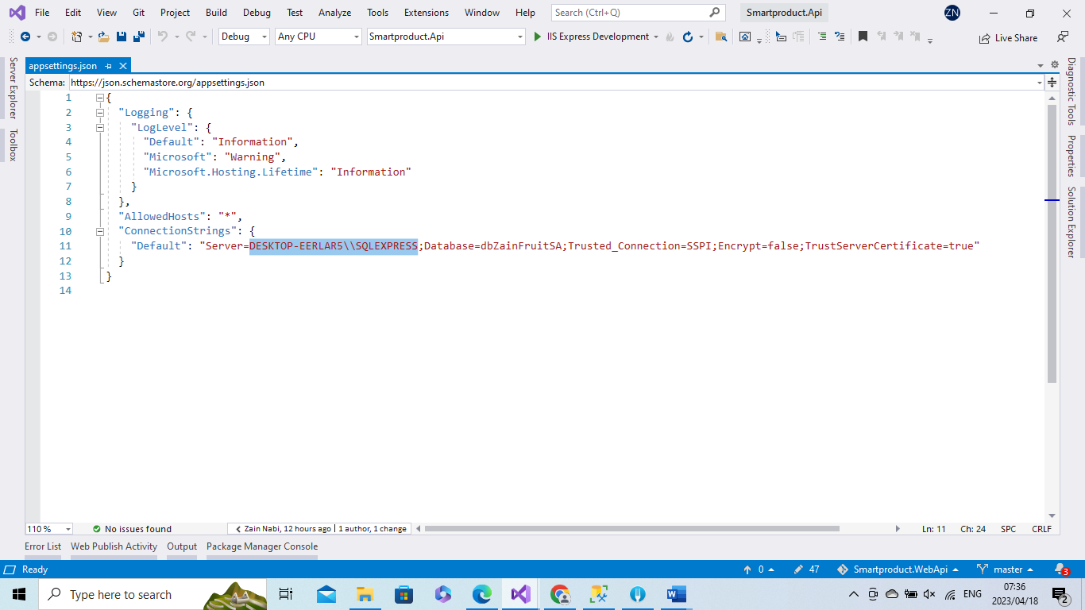

1. This server name can be obtained directly from sql server

# Debugging Visual Studio Solution API(Visual Studio 2019)

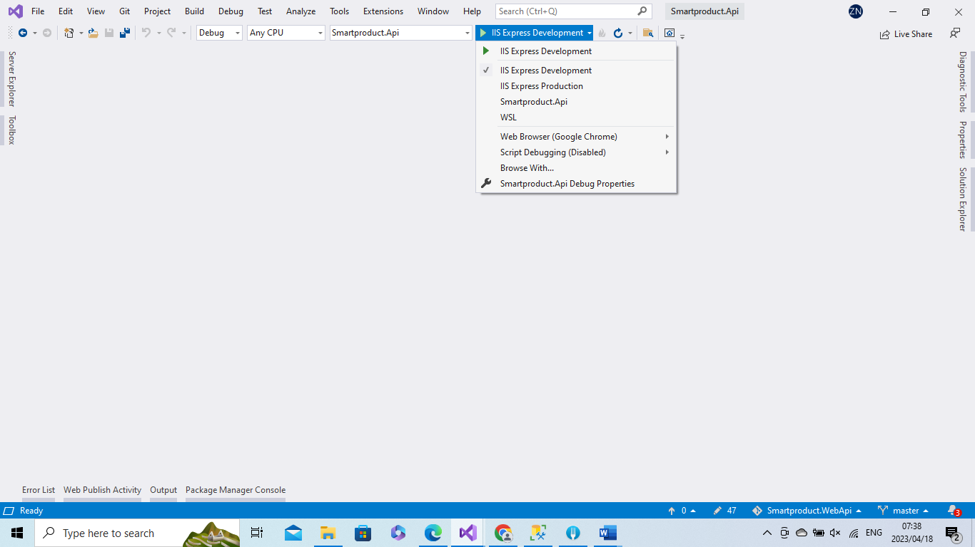

1. Ensure debugger set to use IIS Express Development and hit the Play button
2. A new browser will open up with api documentation

# Debugging Visual Studio Solution Web(Visual Studio 2019)

1. Ensure debugger set to use IIS Express

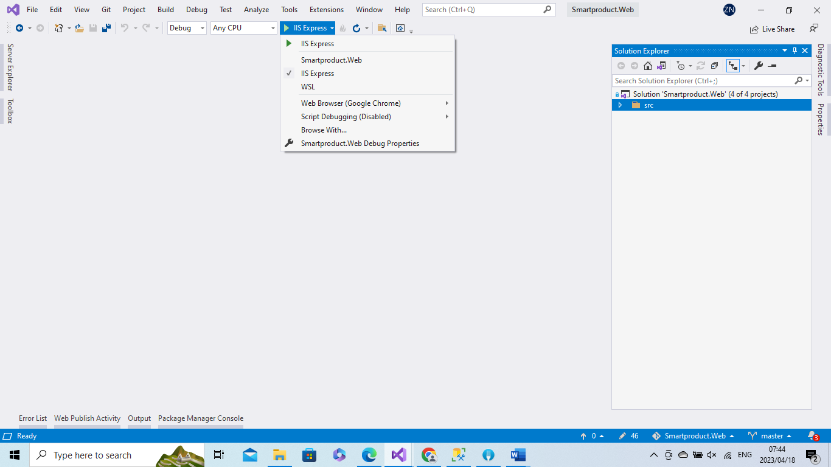

1. Once saved hit the play button and new browser window will open